FREQUENTLY ASKED Q &A’s for new & not so new NPs ... as of 23 March 2019

2018 Legislation Changes Summary related to the Omnibus Bill:

These amendments herald historic changes that will enable competent health practitioners to better use their skills for the benefit of the people they work with, the health workforce and the New Zealand health system as a whole, was a direct result of years of active lobbying by NPNZ and the College of Nursing Aoteoroa, the Chief Nurses Office & working parties.
- Changes across eight Acts amend references to medical practitioners to include health practitioners including nurse practitioners, registered nurses and, in one instance, pharmacist prescribers.
- Seven of the amendment Acts with their new terminology will commence on 31 January 2018 and the Transport Amendment Act will commence on 8 November 2018.
- The amendments enable competent health practitioners (as defined under the Health Practitioners Competence Assurance Act 2003or HPCA Act) working within their prescribed scope of practice (e.g. registered nurses) to carry out new roles as defined by the amended Acts.
- This does not mean that all health practitioners regulated under the HPCA Act will be able to undertake all the amended statutory functions.
- The Ministries of: Health; Transport; Business, Innovation and Employment; and Social Development are responsible for the affected legislation. Other agencies, including ACC and the New Zealand Police, will also need to implement the changes.
AMENDED ACTS:
Holidays Act 2003: Health practitioners are now able to certify proof of sickness or injury including suitably qualified registered nurses, if their employer and the Nursing Council of New Zealand recognise that they are competent and safe to do so
Burial and Cremation Act 1964: Nurse practitioners can now issue certificates for the cause of death for patients in their care and sign off Cremation Certificates.
Medicines Act 1981: Nurse practitioners are now able to supervise designated prescribers (such as authorised registered nurse prescribers or RN prescriber candidates).
Mental Health (Compulsory Assessment and Treatment) Act 1992: Nurse practitioners, or registered nurses working in mental health, will be allowed to complete a health practitioner certificate for applications for assessment under the Act. An NP will also be able to conduct an assessment examination if approved by the Director of Mental Health. The Director can delegate this approval to the Director of Area Mental Health Service.
Accident Compensation Act 2001: Health practitioners providing treatment to a client will be given the opportunity to participate in preparing clients’ individual rehabilitation plans. Suitably qualified health practitioners will also be able to prescribe aids and appliances.
Oranga Tamariki Act 1989 (formerly the Children, Young Persons, and Their Families Act 1989): Health practitioners will be able to carry out medical examinations ordered by the court when considering whether children or young people have been abused, if the court considers that these health practitioners are qualified for that purpose. In addition, a social worker will be able to ask for medical examinations to be completed by health practitioners qualified for that purpose.
Misuse of Drugs Act 1975: Nurse practitioners, registered nurses working in addiction services and pharmacist prescribers will be allowed to prescribe controlled drugs for the purposes of treating addiction.
Land Transport Act 1998: as of Nov 2018, NPs are entitled to sign off Driver Licensing documentation if it falls within their filed of expertise as a health practitioner. Health practitioners will be able to request blood tests from drivers and assess and report on their fitness to drive. It will be illegal for someone to refuse a blood test from a health practitioner. Other amendments enable health practitioners to take blood, handle evidential specimens and appear in court to give evidence.
ACC :
https://www.acc.co.nz/assets/provider/acc7909-working-together-cotr-providers.pdf

Personal injuries include:
• physical injuries (including fatal injuries)
• work-related gradual process injuries, diseases and infections, e.g. asbestosis or work-related hearing loss
• treatment injuries, i.e. physical injuries sustained while receiving treatment from registered health practitioners.

Mental injuries may be covered if they were caused by a physical injury, a specific event in the workplace or sexual assault or abuse. If you are unsure about advising your clients about possible ACC cover, phone the Contact Centre on 0800 222 070.

NPs can sign ACC initial assessment M45’s and ARC 18’s for ongoing time off work related to an approved ACC claim - either claim can include Sensitive Claims & Gradual process claims (for hearing loss or workplace created injury over time).

From Dec 1 , 2018 All practices will receive extra contributions from ACC to encourage them to provide low-cost visits for injured CSC holders and extend the zero fee visits scheme to children under-14 years. ACC expects most practices will reduce their fees for CSC holders to $18.50, with their dependants charged $12.50. These new rates will also apply to practices working under contract – Rural General Practice and Urgent Care Clinics.

There are separate visit charges for NP, RN, GP & GP/RN combo, however there is yet to be a NP/RN combo charge. ACC continue to be lobbied about this by NPNZ to be in keeping with the Ominbus changes to the Health Practitioner Act. Legislation to enable changes was passed (Jan 2016) ACC minister has indicated in Feb 2019 this situation will be looked at in a review this year.

New Accident Compensation Act 2001 (MBIE¹) – to the extent that health practitioners are willing and able to do so, health practitioners providing treatment to a client will be given the opportunity to participate in the preparation of the client’s individual rehabilitation plans. Suitably qualified health practitioners will also be able to prescribe aids and appliances. Omnibus bill passed– 21 Mar 2017, Changes enacted 31st Jan 2018

NPs can not claim for ACC Designated Doctor visits.

 Tips > ensure your admin staff know to charge your claim at NP rates not at RN rates if working in urban based position or, leave as is if on rural contract. If in urban setting & doing combined care visit with a GP, charge out at GP/RN claim rate as it is invoiced at a higher rate (& you are still essentially an RN).
 If working only with a RN, you can put two claims in for the same patient in one day, one for NP & one for the RN - but only if the patient returns for follow up later in the same calendar day ie for a second dressing if required for a major injury. Or, for an entirely new injury a new M45 should be processed.
 Multiple claims such as this for the same patient will likely be investigated by ACC.
 Ensure you charge out your time per ACC hourly rate to supply additional information when it is requested with pts permission for ACC purposes. Only disclose ACC related information, they do not have outright permission to peruse the patient’s entire record.
 Do forms online for most efficient method of processing of M45/ ARC18 within PMS via BPAC (ACC’s preferred option)

ACC Consultation processes as at March 2019

ACC’s Health Services Strategy focuses on partnering with health providers to develop new ideas, and design and test new ways of working to drive better outcomes for our clients. Through ACC’s General Practice Connect project they initiated a relationship with GP NZ, Royal College of GP’s and the NZMA, however through listening to feedback ACC recognised that this is insufficient to represent the entirety of the sector and enable our strategic intent. As a result ACC would like to form a Primary Health Care Sector Engagement Group (PHC SEG) to obtain insights, advice and guidance to shape our design initiatives and business as usual work for our Primary Care Programme. NPNZ have been offered a place on the PHC SEG.
ACC Levies for self-employed NPs:

To work out your ACC levies
https://www.acc.co.nz/for-business/paying-levies/paying-levies-work-or-own-a-business/
Select Nurse Practitioner Business Industry Code: Q853967
Estimate how much your business levies will be for the year, so that you know what to expect when your invoice arrives.

Auditing your practice:

Use Query Builders in Medtech 32 or other PMS software to keep track of what you are doing, no of patients seen & easily countable data such as frequently seen conditions, immunisations given, laboratory and radiology investigations ordered, or scripts written.
 Tip > BPAC NZ have available ‘MyBPAC’ a personalised audit of some laboratory and community prescribing practices of individual NPs in PHC, which is available to via their web page [since 2013 pilot]

http://www.bpac.org.nz/

Once on the site, log into ‘MyBpac’ & create an account for yourself follow the prompts or contact BPAC directly for help

 Tip > Other ways of Auditing:

Place a direct request to your DHB lab to provide a log of what you have ordered. Radiology services can probably provide this type of log as well. Classifications & Demographics can track your workload & populations types.

NEW Children, Young Persons, and Their Families Act 1989 (MSD) – Health practitioners will be able to carry out medical examinations ordered by the court when considering whether children or young people have been abused, if the court considers that these health practitioners are qualified for that purpose. In addition, a social worker will be able to ask for medical examinations to be completed by health practitioners qualified for that purpose. Omnibus bill passed – 21 Mar 2017, Changes enacted 31st Jan 2018

Driver’s Licencing:

NP’s can as per LTSA legislation complete applications for Driver’s licensing.
THE essential resource is the “Medical aspects of fitness to drive A guide for health practitioners”
https://www.nzta.govt.nz/assets/resources/medical-aspects/Medical-aspects-of-fitness-to-drive-A-guide-or-health-practitioners.pdf

There a two formats to DL’s forms to use – hard copy [ easier to access but easier to miss things out] or electronic format [which will not send until all essential fields completed] but, is a little trickier - you need to register with the Dept of Internal Affairs “ Real Me “ login as a first step on the link below;
https://glsgwpro01.transactpro.nzta.govt.nz/gateway/access.aspx
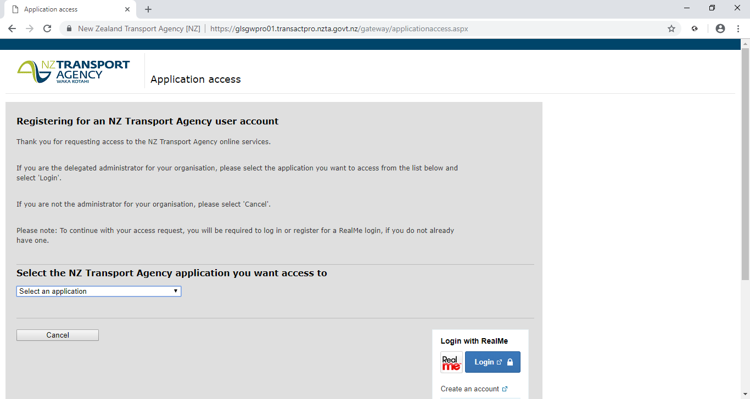
Once you have registered with Real Me,
Next Steps:
1. You may be contacted by an NZTA representative in respect of your application.
2. A decision on your application is expected to take up to 10 working days.
3. We will notify you by email once the process has been completed.
If you have a query about your registration application, please contact the NZ Transport Agency by ph: 0800 108809

To acquire a NZ Transport user account, you may need to work with your practice administer from here on.

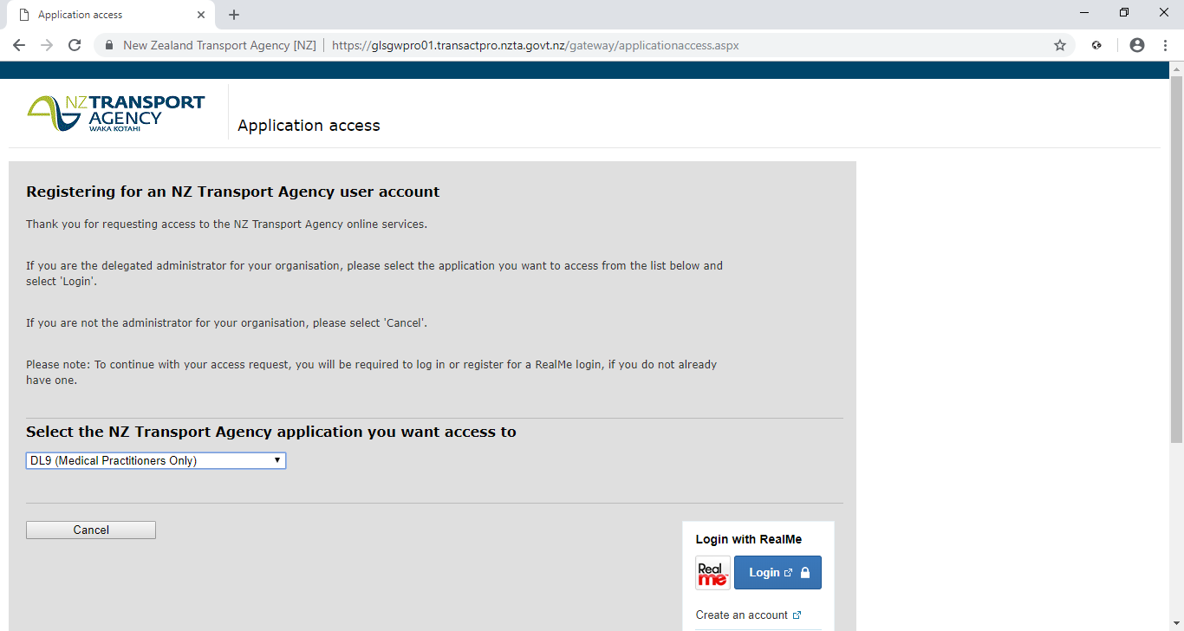

For ALL general information from LTSA https://www.nzta.govt.nz/driver-licences/

From 8 November 2018, registered nurses and nurse practitioners, working within their scope of practice, can now issue medical and eyesight certificates for driver licensing.

Who must have a medical certificate?
Some drivers must have a medical or eyesight certificate to apply for or renew a driver licence or endorsement – drivers who:
- are applying for or renewing a heavy vehicle licence (class 2,3,4,5) and who’ve not provided a certificate within the last five years
- are applying for or renewing endorsements for passengers (P), vehicle recovery services (V), driving instruction (I) or testing (O) and who’ve not provided a certificate within the last five years
- have a medical condition that may affect their ability to drive safely
- are 75 years old or more and applying for or renewing any licence or endorsement
- we have asked to provide one.
The evidence we require is a medical or eyesight certificate:
- supplied by New Zealand registered health practitioner (optometrists, ophthalmologists, general practitioners, registered nurses, nurse practitioners, neurologists and occupational therapist driving assessors)
- not more than 60 days old.
A medical declaration must be completed for any driver licence application form. This asks you to declare any conditions that may affect ability to drive safely, including:
- Diabetes
- Locomotive joint or limb problems
- Strokes
- Nervous or mental disorders
- High blood pressure
- Seizures, fits, convulsions, epilepsy
- Serious injuries (eg head or spinal injuries)
- Visual disturbances (eg cataracts, double vision, glaucoma)
- Cerebral vascular accidents/disease
- Cognitive impairment
- Any other condition that may affect ability to drive safely, including fatigue, disabilities and conditions such as dementia.

Use the guide for medical assessments
Placing licensing restrictions on a driver is a serious matter. But so are the consequences of allowing someone to continue to drive if they are unfit to do so.
We’ve produced Medical aspects of fitness to drive: a guide for health practitioners [PDF, 1.1 MB] to set out your responsibilities and guide you in assessing a person’s fitness to drive.

Have concerns about an older driver?
If you’re satisfied that an older person (75 years+) is medically fit but have concerns about their ability to drive safely, you can recommend that they sit an On-road Safety Test.
Simply tick the box for this recommendation on the NZ Transport Agency pre-printed medical form. The driver licensing agent will then arrange the test when the person presents their medical certificate.

Conditions you can recommend; You can recommend conditions to be imposed on a driver’s licence to improve their driving safety. Commonly imposed conditions include:
- Correcting lenses must be worn at all times while driving.
- Only vehicles with an automatic transmission may be driven.
- Vehicle must have rear view mirrors on both sides.
- Must not drive during the hours of darkness.

LTSA is here to help
While you have a responsibility for making recommendations about licence conditions, LTSA have the responsibility of imposing them. If you have any concerns about a particular case, please write to our Chief Medical Adviser at the Transport Agency's Palmerston North Office

Changes to health practitioners that can issue certificates. The Land Transport Act 1998 and associated Driver Licensing Rule previously limited fitness to drive assessments to general practitioners, optometrists and occupational therapists. Under law changes that came into effect on 8 November 2018 appropriately qualified nurse practitioners and registered nurses, working within their scope of practice, will also be able to carry out a fitness to drive assessment.
These changes were enacted by the Land Transport Amendment Act 2016. For example, references in section 18 of the Land Transport Act to a 'medical practitioner or optometrist' are replaced by 'health practitioner'.
This change reflects New Zealand's changing health care environment and recognises that, for example, appropriately qualified and competent nurse practitioners and specialist registered nurses have the expert clinical knowledge and skills to assess fitness to drive.
Scope of practice is defined in the Health Practitioners Competence Assurance Act 2003.Section 8 of that Act makes it clear that health practitioners must:
- have a current practising certificate issued by the responsible authority (such as the Nursing Council of New Zealand)
- not practise outside their scope of practice unless permitted to do so by the scope of practice
- perform that service in accordance with any conditions stated in the scope of practice.
Responsible authorities are responsible for defining scopes of practice, which can include a description of tasks commonly performed by that profession (section 11 of that Act).

Medical certificates for commercial drivers
We want to ensure you won't cause an accident through a health-related incident when you're responsible for the lives of passengers or driving large vehicles on public roads. It's important to recognise you're also on the road for longer than the average Kiwi driver. If you need a heavy vehicle licence (classes 2, 3, 4 or 5), or a P, V, I or O endorsement, this applies to you.

Most commercial drivers must provide a medical certificate
To show that you're in good health you must:
- provide an original medical certificate (not older than 60 days) that has been completed by a New Zealand-registered health practitioner, or
- have previously provided a medical certificate for a P, V, I or O endorsement, or a truck licence, within the last five years.
However, if you've developed a medical condition that could affect your driving or, have a medical condition that has worsened since presenting your last certificate, you'll need to provide a new medical certificate regardless.

Getting a medical certificate
- Ask your health practitioner to complete a Transport Agency medical certificate for you. The certificate will either state that you're safe to drive or, set out the conditions under which you can drive safely.
- Your health practitioner will have copies of the form. The Transport Agency have issued guidelines so it is clear which medical conditions are and are not acceptable.
- You're responsible for the cost of getting your certificate. The cost varies between medical centres.

Sometimes an occupational therapist check is required Where a health practitioner has concerns over whether you're medically fit to drive the classes or endorsements you're applying for, they commonly seek a second opinion. They may refer you to an occupational therapist for a driving assessment.
This assessment involves an approximately two-hour off-road assessment, which may be followed by a 50–60-minute on-road assessment.
See what's involved in an occupational therapy assessment
The therapist then sends a report back to your health practitioner. When issuing your medical certificate, your practitioner will take the therapist's report into consideration – for example they may recommend you only drive vehicles with an automatic transmission.

Omnibus bill passed– 21 Mar 2017. Legislation completed & enacted in Nov 2018. NPNZ worked with LTSA to ensure recognition of NPs in this role

 Tip > Resource to have to hand http://www.nzta.govt.nz/resources/medical-aspects/5.html
NEW Land Transport Act 1998 (Transport) – NP’s are be able to request blood tests from drivers and assess and report on their fitness to drive. It will be illegal for someone to refuse a blood test from an NP. Other amendments enable NP’s to take blood, handle evidential specimens and appear in court to give evidence. Omnibus bill passed – 21 Mar 2017 enacted 31st Jan 2018

Death certificates / Life extinct certificates:

Life extinct certificates can be signed off by either an NP or RN (Oct 2015).

NEW https://deathdocs.services.govt.nz/welcome [2018] Death Documents now fully available electronically, the new service that allows medical practitioners and nurse practitioners to complete medical certificates of cause of death and cremation forms on-line has been in operation since 1 March 2018.
Following feedback from early adopters of the first release some small enhancements were made to the system and additional training resources have been added. Feedback since has been very positive.
 Tip > Visit https://deathdocs.services.govt.nz and add it to your Favourites.
Getting started
To start you may find it helpful to view this short video on the completion of the online forms: Welcome to Death Documents – YouTube: Ministry of Health tutorial (9 mins, 32 secs)
A downloadable podcast by 'Ward Calls' host Dr Sam Holford (Middlemore Hospital, Auckland) about verifying and certifying death is available at this website: Verifying and Certifying Death – Ward Calls. This podcast is particularly good if you are new to certifying death

There are some things you can do now to make it quicker to use Death Documents when you have a certificate to complete:
- Make sure you have a RealMe login [ If you don’t have one yet you can create a RealMe login in a couple of minutes when you first visit Death Documents – just click Login
- Find your HPI-CPN (Health Provider Index – Common Person Number) If you’re a nurse practitioner, you can find it by searching your own registration on the Nursing Council website

- Register with Death Documents o Log in to Death Documents and complete your registration. You only need to do this once and your details will be automatically populated onto any death documents you complete.
https://deathdocs.services.govt.nz/dashboard

 Tip > if something isn’t working or doesn’t make sense you can get in touch with the
Ministry of Health Contact Centre.
Freephone: 0800 505 125 Email: customerservice@moh.govt.nz

If Death Documents isn’t working for you, you can use the old paper forms.
Death Documents intend to be as user-friendly as possible so please let them know what it was that didn’t work for you by completing the form: Death Documents Feedback – Survey Monkey website
NEW Burial and Cremation Act 1964 (Health) – NPs can now issue death certificates and Cremation Certification for patients in their care. NPNZ, MOH’s Chief Nurse & Working party successfully lobbied for change since start of 2014. Omnibus bill passed– 21 Mar 2017, enacted 31st Jan 2018. NPNZ exec worked closely with govt to test and amend the electronic forms.
First trimester Antenatal Visits:

NPs are not currently (2014) funded to deliver this package of care as it is tied to Section 88 funded services which are claimed exclusively by Lead maternity Carers/ GPs. An NP may assess & diagnose pregnancy, miscarriage, or ectopic pregnancy & workup the patient: order first AN blood tests, do smear & swabs, prescribe routine & PRN antenatal meds, however the GP must sight the patient to lodge the claim for first trimester Antenatal care in the PHC setting.
NPNZ is lobbying MOH for change of funding structure. Section 88 is a highly problematic Notice.
NO movement – since March 2016

Laboratory Investigations:

Latest DHB review of laboratory Services was Oct 2013, officially deems NP’s hold limited access to testing, this is variable per DHB at present depending on how tightly lab services are watching their budget. Histology requests (other than smear cytology) and expensive tests such as TTG (marker for Coeliac Disease) are generally declined in the PHC setting and NPs are asked to defer the request to a medical colleague to order, this may be different for other NP scopes.
NPNZ continue lobbying to achieve same accessibility as GPs & LMC’s for tier one testing, & tier two testing with consultant consultation/approval. In March 2018 DHB Laboratory Services Review have indicated NPs will be consulted in the next review.
(See document ‘Completion of the Laboratory Schedule Review Oct 2013’ on www.DHBsharedservices.health.nz)

 Tip > It is recommended to meet with your laboratory manager to discuss what is in their contract covering NP ordering.

Immunisations:

NPs can prescribe scheduled immunisations in accordance to their population group/ client base NPs have full authority to Rx and administer the vaccines on the Schedule.
 Tip > prescribe travel vaccines as you would any other medication apart from Yellow Fever & Mantoux/BCG as these vaccinations are gazetted vaccines and require special training and certification to order and administer.

NPs are able to claim for scheduled immunisations given just as a General Practitioner can.
NPNZ are lobbied for change to this inequity – [Jan 2016]

Insurance Medicals:

NEW Kiwi Saver has recently acknowledged NP as entitled to sign off certification of their documentation relating to early withdrawal of funds due to Serious Illness in July 2017
http://www.workplacesavings.org.nz/assets/Uploads/WSNZ-Serious-Illness-Processing-Guidelines-Updated-November-2018.pdf
NPNZ successfully lobbied for change - July 2017
Otherwise, NP sign off is Not Accepted where the information must be completed & signed off by a GP/ Medical Officer.

Office of the Chief Nurse MOH:

Margareth Broodkoorn, Chief Nurse, MoH & her team of Nursing Advisors are very happy to assist NPs facing barriers to practice & want to hear from you - as does NPNZ, we are constantly working to address barriers other issues that NP’s face, including IT & workforce development.
Jane Bodkin holds the NP portfolio in the OCN Email; Jane_Bodkin@moh.govt.nz

https://www.health.govt.nz/our-work/nursing/nursing-leadership/chief-nursing-officer/office-chief-nurse

Off work certificates:

NEW Holidays Act 2003 (MBIE) – Nurse practitioners are now able to certify proof of sickness or injury. Omnibus bill passed– 21 Mar 2017, enacted 31st Jan 2018
 Tip > if it is an ACC M45 off work certificate is including as part of the claim, or an ACC ARC 18 certificate.

NEW Mental Health (Compulsory Assessment and Treatment) Act 1992 (Health) – allows an NP, or RN working in mental health, to complete a health practitioner certificate for applications for assessment under the Act. Omnibus bill passed– Mar 2017, enacted 31st Jan 2018 A nurse practitioner will be able to conduct an assessment examination if approved by the Director of Area Mental Health. The Director can delegate this approval to the Director of Area Mental Health Service

Omnibus Bill [2017]:

The amendments heralded historic changes that will enable competent health practitioners to better use their skills for the benefit of the people they work with, the health workforce and the New Zealand health system as a whole, & was a direct result of years of active lobbying by NPNZ, and the College of Nurses Aotearoa.
‘The Health Practitioner Safety Regulation Bill’ passed before the NZ Parliament on 21st March 2017 to address barriers to NP practice covered by 8 Acts of legislation; The Ministries of Health; Transport; Business, Innovation and Employment; and Social Development are responsible for the affected legislation. Other agencies, including ACC and the New Zealand Police, will also need to implement the changes. The aim of the changes is to make health services more flexible and available when people need them. It also acknowledges and makes better use of advanced knowledge and skills in the health workforce
Eight Acts were given the Royal Assent on 7 November 2016. They were the:
- Accident Compensation Amendment Act 2016
- Burial and Cremation Amendment Act 2016
- Children, Young Persons, and Their Families Amendment Act (No 2) 2016
- Holidays Amendment Act 2016
- Medicines Amendment Act 2016
- Mental Health (Compulsory Assessment and Treatment) Amendment Act 2016
- Misuse of Drugs Amendment Act 2016
- Land Transport Amendment Act 2016
Pay scales for NPs:
YOU need support as new Nurse Practitioners do face lots of new challenges to your practice and challenges in embedding a new role/ model of care.
Most NP’s will be on the equivalent of the Step 8 of the Senior Nurses scale in the NZNO DHB MECA, if they are starting at the lower end of the senior nurse salary (as per DHB MECA) ensure there are stated time periods to review the salary and agree on a procedure to review proof of effectiveness etc. For DHB NPs it is an annual increment up to 4 increments [?].
If you are looking at an individual contract with a private provider, NPNZ would also recommend;
- adequate Annual Leave (up to 6wks),
- study leave to cover the 40hrs a year professional development a year that Nursing Council New Zealand require
- professional development budget of at least $5-6 thousand
- reimbursement of fee for the Annual Practicing Certificate
- & one set of professional fees, ideally one that will provide indemnity insurance.
- paid clinical supervision monthly, is also very advisable
- … take it home & get advice Before you sign anything
- Note few PHC providers are part of the PHC Meca

Prescribing:

As a new Prescriber: it is recommended you introduce yourself in person or by letter (if in a large centre) to the Pharmacies your patients are most likely to present your scripts to, it familiarises the Pharmacy with developing NP practice & is good for relationship building.
Medsafe regularly provides Prescriber Updates and other information on their website, and offers a service where practitioners can sign up for email information and alerts through the links below.
1. Medsafe web page: http://www.medsafe.govt.nz
2. Subscribe to Prescriber Update and the Early Warning System http://www.medsafe.govt.nz/profs/subscribe.asp

From 1 July 2014, the Medicines Amendment Act 2013 and Misuse of Drugs Amendment Regulations 2014 came into effect. The change allowed NPs to be ‘Authorised Prescribers’ within their field of practice ie PHC, youth health, or older persons care. NPs are no longer limited to the list of drugs originally approved for NP use as ‘Delegated Prescribers’. NPNZ & Office of Chief Nurse successfully lobbied change.

NEW The Medicines Act 1981 (Health) – Enables nurse practitioners to supervise designated prescribers. Omnibus bill passed– Mar 2017, enacted 31st Jan 2018

NEW Misuse of Drugs Act 1975 (Health) – Will allow nurse practitioners, registered nurses working in addiction services and pharmacist prescribers to prescribe controlled drugs for the purposes of treating addiction. Omnibus bill passed– Mar 2017, enacted 31st Jan 2018

NEW Prescribing controlled drugs in treatment: section 24A of MODA
The document ‘Prescribing Controlled Drugs in Addiction Treatment: Section 24 Misuse of Drugs Act 19754’ has been integrated into section 12 of the OST guidelines 2014. It should be read alongside these guidelines and other relevant best-practice guidance.
Section 24A of MODA governs the prescribing of controlled drugs to treat dependence to controlled drugs. There are two pathways of prescribing as described below;
Health practitioners working in a Specified Place
The legislation does not restrict the period of authorisation of a health practitioner working at a Specified Place (Pathway One). In practice, however, the lead clinician should review the approval of the authorisation regularly in line with the guidelines. This regular review should involve assessing the practitioner’s professional development, including continuing education and participation in appropriate clinical networks.
A nurse practitioner, designated prescriber nurse or designated prescriber pharmacist should, as a minimum, meet all of the criteria outlined in section 10.2: Workforce training and professional development of the OST guidelines 2014.
Health practitioners working in primary care
In accordance with the OST guidelines 2014, health practitioners accepting transfer of a client from a specialist service to primary care can continue to prescribe controlled drugs to treat the client’s addiction with the authority of the lead clinician or an approved medical practitioner working in the service (Pathway Two).

Controlled drugs:

such as Opiates or other drugs of addiction (class C drugs), can be supplied for the maximum of
ONE MONTHS supply in line with GP prescribing practice.
Need to be done on MOH Controlled Drug Supply form H572 (triplicate copy) an ordinary prescription will not be accepted by a pharmacy.
All three copies must be presented to a pharmacy for dispensing.
The number of the script, patient’s name & drug dosage & amount scripted with the prescriber’s name and signature must be recorded in a controlled drug book which is to be kept in a double locked safe/ space along with any unused script pads.
The prescriber (NP) is accountable to keep this standard and can be audited at any time.

 Tip > keep a record of the CD script # and details of the prescription on the prescription tab within your PMS records

For a small amount of controlled drugs oral or injectable stock (i.e. Morphine), to have to hand for PRN use, complete the in triplicate controlled Medication form & present all three copies must be presented to the dispensing pharmacy. Any medication stock of this nature is to be managed as explained above for safety, transparency and auditing purposes.

Nurse Practitioner Supply Order:

for limited stock supply of non-controlled medication & medical appliances (HCG, child/adult Spacers, low / high range peak flow meters, blood glucose test strips) to provide urgent one-off dispensing. Rural NPs are entitled to order a much wider range of Rxs than urban NPs.
Supplies of these forms may be obtained from Wickliffe Ltd, telephone 0800 259 138, & quote reorder no. 74169
Use the same MOH pre-printed Green Practitioner Supply Order Forms No# 74169.
The rules regarding the care of these forms is the same as the controlled drug forms & it is your responsibility to ensure that they are accounted for if in your possession.

Standing Orders:

NPs are be able to supervise designated prescribers (such as authorised registered nurse prescribers or RN prescriber candidates). MOH lobbied by NPNZ to change currently standing legislation regarding standing orders. Omnibus bill passed– Mar 2017, enacted 31st Jan 2018

Special Authority (SA) Applications:

The medications listed for SA are always changing according to funding schedules decided by Pharmac at any given point, and the medications listed which NPs can initially apply for on behalf of their pts is somewhat limited in comparison to a Vocationally Registered GP or Specialist. Some drugs SA’s may be renewed by an NP although they must be initially applied for by a specialist. There are other drugs including nutritional suppliments, may only be applied for at any stage by a vocationally registered GP/ Specialist or Dietician.
All SA treatments are required to meet certain pre-set criteria to gain approval.
SA can be accessed by either electronic application with a 3 minute turn around response inbox within electronic PMS, or by faxing a completed hand written form & faxing it to 0800 505 125 approval can take several weeks using this method.

Increasingly electronic PMS are geared to process NZNC registration numbers through the same portals that accept NZMC colleagues can use for an instant response of acceptance/ decline of SA applications. SA application process in MedTech is available for those using MedTech at the March 2015 upgrade- just follow the notes they send out and it will be good to go
 Tip > this option requires accessing a Digi-Cert (proof from your DHB Manager & Clinical Director that you are able to hold such responsibility on behalf of your employer)

Contact the Online Helpdesk on 0800 505 125 or, email: onlinehelpdesk@moh.govt.nz. regards Electronic Special Authority.
In order to send you the required application forms, you need to provide the following details:

• Pharmacy, Hospital, Practice Name
• Address
• Nurses Council Number
• Practice Management Software at your practice i.e. MedTech, Next Generation

If you wish to discuss your enquiry further, please telephone Online Helpdesk on 0800 505 125
On-line Helpdesk Sector Services National Health Board Ministry of Health Email: onlinehelpdesk@moh.govt.nz

Once you have gained the Digi –Cert, contact your IT dept to load it onto your computer system. Once loaded, a NP can directly access Pharmac SA’s online through a special portal.
Unfortunately, the portal does not link directly back into your PMS.
Once SA has been granted you as the prescriber will be required to write the CHEM no and expiry date on the prescription for the said SA medication. Pharmacy will not dispense without this. The HPCA can audit your records at any time if there is any question relating to your delivery of care.
NPNZ are lobbying MOH & Pharmac for changes to enable NPs to be equitable prescribers of SA drugs as per Vocational GP lists– March 2017

 Tip > If you do not know the SA no and expiry date for any medication a patient is already on, phone the patient’s pharmacy to ask for it.

 Tip> download the latest SA forms from; http://www.pharmac.govt.nz/patients/PharmaceuticalSchedule/SAForms

 Tip > These documents are part of your patients medical file.
Scan and copy hand written forms into electronic records,
OR, copy & paste SA approval/ decline into the Inbox of your pts PMS.

Publicity:

Inform both your colleagues and the public if you are a new NP, or your role is a new one.
Even though NPs have been around for nearly 20yrs in NZ many people both colleagues & the public have never experienced working with one, so give them the chance to read the low down on what is an NP before they come in for their appointment or prior to their care in a department.
 Tip > make a laminated flyer to leave at reception counter or place on the wall such as the simple example to follow.
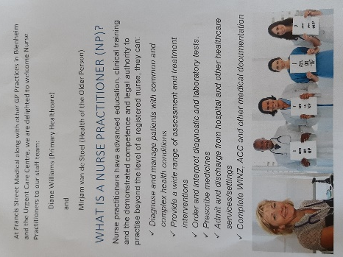

Radiology DHB:

Although NPs are in theory entitled to order radiological investigations to diagnose or rule out conditions, in reality the Head Radiologist for each DHB gate keeps this as it is on their say so as to whom is approved to order in any particular DHB. (see Radiology letter March 2009 College of Radiologists letter.pdf )

NP ordering of Ultrasound and CT is becoming far more accessible, though may remain dependent on DHB contracts. This may not be the case for say for specific scopes e.g. Urology/ PHC NP ordering Renal Ultrasound, or an Older Persons/ PHC NP ordering a CT scan for dementia diagnosis.
DHB protocols do vary, however, NPs can not order publicly funded Ante-natal Ultrasound scans for TOP referrals or urgent Ante Natal care as the funding for these investigations are tied up with Section 88 funding to which an NP is unable to access [ unless you happen to hold dual certificate of Midwife / Lead Maternity Carer as well].

 Tip > a pelvic USS for Gynaecological investigation or lower quadrant abdominal pain is permissible and may rule out an Ectopic pregnancy.

MRI ordering is generally not accessible by NPs or GPs and are generally considered ‘specialist only’ to rationalise use/ expenditure however, it is acknowledged that some DHBs allow niche specialist field NPs to enable MRI ordering with consultant support.
NPNZ are lobbying the MOH Chief Nurse for change to this ruling to gain same access as GP colleagues and for a NZ wide agreement for equity to access across all DHBs.

Radiology Private:

There is far greater acceptance by Private Radiology Services for NP ordering examinations as the patient pays in full or partially relating to ACC injuries including ultrasound and plain films.
An NP can privately order a scan for dates as it is the patient who is paying for this service.

 Tip > NPs can recommend mammography for national breast screening purposes and refer for diagnostic mammogram/ breast ultrasound via DHB pathways. If your patient is willing to pay for a private radiology appt there seems not to be the same issue.

Work & Income:

NPs can as of Nov 2018 complete & sign off Work & Income’s certifications:

‘Work Capacity Certificate’
‘Child Disability Allowance’
‘Adult Disability Allowance’
‘Dependent Persons Benefit’
‘Supported Living Allowance’ (nee Invalids benefit) under the Social Security Act 1964.
An NP can now also apply for funding to complete Designated Dr certifications.
NPNZ actively lobbed for change for many years & MSD legislation was amended in 2018 to meet the provisions set out in the Omnibus Bill of 2016.

FAQs compiled by Di Williams NPNZ Exec, last up dated on 23 March 2019
Please feel free to email Di with any additions or amendments as you come across them in your practice. Dj124395@gmail.com

